Name: Sapargali Temirlan
Group: SE-2403
Instructor: Kozhakhmet Zhaksylyk
PART 1
TASK 1
Deriverables
All deliverables such as the contract files and e.t.c, are inside same directory as this document.
Test suite:
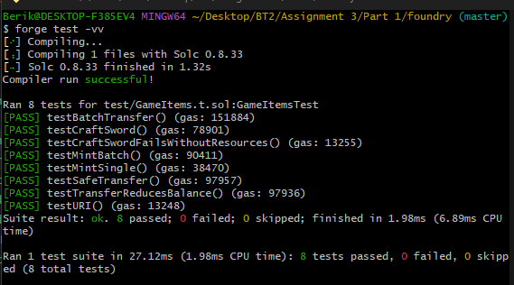
ERC-1155 vs separate ERC-20 + ERC-721
Gas Efficiency Comparison
ERC-1155's Key Innovation:
Batch operations. A single safeBatchTransferFrom call can transfer multiple token types simultaneously, while ERC-20 + ERC-721 would require separate contract calls for each token type.

Deployment Gas
ERC-1155: One contract (~2-3M gas) handles all token types (fungible, semi-fungible, non-fungible)
Separate contracts: Each ERC-20 (~1.5M gas) + each ERC-721 (~2M gas) = significantly higher deployment costs for multiple token types
Transaction Gas (per operation)
Operation | ERC-1155 | ERC-20 + ERC-721
Transfer 1 fungible token | ~45k gas | ~50k gas (ERC-20)
Transfer 5 fungible types | ~60k gas (batch) | ~250k gas (5 separate calls)
Transfer 1 NFT | ~45k gas | ~60k gas (ERC-721)
Transfer 5 NFTs | ~60k gas (batch) | ~300k gas (5 separate calls)
Approve operator | ~45k gas (once for all) | ~50k per contract
Bottom line: ERC-1155 saves 70-80% gas when batching multiple token types.
ERC-1155 Advantages
Single contract: Simpler upgrades, one address to track
Native batch operations: Ideal for game inventories, marketplace bundles
Unified approval: One setApprovalForAll covers all token types
Mixed token types: Fungible (quantity > 1) and non-fungible (quantity = 1) in same interface
ERC-1155 Disadvantages
Less standard tooling: Fewer wallets/exchanges support ERC-1155 vs ERC-20
No native decimals: Fungible tokens lack ERC-20's decimals() convention
URI complexity: Metadata URI often requires ID substitution patterns
Overkill for simple cases: If you only need one fungible token, ERC-20 is simpler

Use ERC-1155 when:
Building games with multiple resource types and items
Need batch transfers (marketplace checkouts, inventory management)
Combining fungible currencies with NFTs in same ecosystem
Managing semi-fungible assets (event tickets, limited editions)
Use separate ERC-20 + ERC-721 when:
Only one fungible token needed (standard token)
Integration with existing ERC-20/ERC-721 infrastructure required
Clear separation of concerns preferred
Simpler auditing surface desired
Real-World Example: Game Items
// ERC-1155: One contract handles GOLD (fungible), WOOD (fungible),
// LEGENDARY_SWORD (non-fungible), DRAGON_SHIELD (non-fungible)

// Batch mint all starting items in ONE transaction
function startGame(address player) external {
uint256[] memory ids = [GOLD, WOOD, LEGENDARY_SWORD];
uint256[] memory amounts = [1000, 500, 1];
_mintBatch(player, ids, amounts, ""); // ~90k gas
}
With separate contracts, this would require 3 separate mint calls across 2-3 contracts, costing 3-4x more gas and more complex code.
Conclusion
ERC-1155 offers superior gas efficiency for multi-token systems at the cost of some ecosystem maturity. For single-token needs, stick with ERC-20/ERC-721. For games, marketplaces, or any system with 3+ token types, ERC-1155 is the clear winner.
PART 1
TASK 2
Deriverables
All deliverables such as the contract files and e.t.c, are inside same directory as this document.
Test suite:
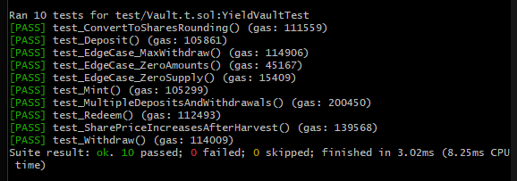
Real-World Use Cases of ERC-4626
ERC-4626 is a standardized interface for tokenized vaults that has revolutionized DeFi composability. Here are three major real-world applications:
Yearn Finance Vaults
Yearn was the pioneer of yield aggregators, and their v3 vaults are fully ERC-4626 compliant. Each vault accepts a single underlying asset (e.g., DAI, USDC, stETH) and automatically deploys it across multiple lending protocols, liquidity pools, and strategies to maximize yield. The standard allows other protocols to seamlessly integrate with Yearn vaults for example, a lending protocol can accept yvDAI (Yearn's DAI vault shares) as collateral, knowing exactly how to convert between shares and underlying DAI using convertToAssets().
Aave aTokens
Aave's interest-bearing aTokens (e.g., aUSDC, aETH) follow the ERC-4626 pattern. When users deposit assets into Aave, they receive aTokens that accrue interest in real-time through a rebasing mechanism. While aTokens don't implement the full ERC-4626 interface natively, wrappers like AaveV3ERC4626 bridge the gap. These vaults enable aTokens to be used in any protocol that supports ERC-4626, from liquidity pools to collateral managers, creating a unified interface for interest-bearing assets.
Compound cTokens & Euler eTokens
Compound Finance's cTokens and Euler's eTokens are early examples of tokenized vaults. ERC-4626 formalizes what these protocols already did: represent a claim on deposited assets plus accrued interest. The standard's key innovation is its rounding specification (previewDeposit, previewMint, etc.), which ensures predictable behavior for smart contracts. For example, a protocol building a leveraged yield strategy can precisely calculate how many shares to mint for a given deposit, preventing rounding errors that could be exploited.
Why Standardization Matters
Before ERC-4626, every yield-bearing token had different interfaces Yearn had pricePerShare, Aave used balanceOf with rebasing, Compound had exchangeRateCurrent. This fragmentation made composability difficult. With ERC-4626, any vault can be plugged into any protocol that understands the standard, enabling "vault legos" where strategies can be nested and combined without custom adapters. The standard has been adopted by over 100 protocols and is considered the gold standard for tokenized vaults in DeFi.

